Chapter 6, Problem 21.

Determine the equivalent capacitance at terminals a - b of the circuit in Fig. 6.55.

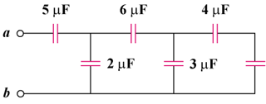
12 µF

Figure 6.55
For Prob. 6.21.

